Cimarron High School News
September 2019 Edition
SHOUT OUTS!
*Shout out to our students who were “Rising Up” during the first few weeks of school.
*Shout out to our custodial and maintenance staff for having our buildings ready to go for the start of school...the buildings and classrooms were beautiful! Thanks to all of you for your hard work over the summer!
*Shout out to our teachers for their work in planning, revising, attending professional development, etc. over the summer. Way to Rise Up to improve your practices in the classrooms.
*Shout out to all our parents and families who came to Back to School night and supported their children and the school. Thank you so much for your support!
*Finally, a huge shout out and thank you to those that donated school supplies, including Vicky Harper, Kristine Willis, and First National Bank of Raton! We appreciate your support and generosity!

CIMARRON RAM BAND
I am excited to begin my tenure as the Cimarron Schools Band Director and look forward to a successful year with your students. Thank you for the welcome! I feel lucky to be part of such a supportive community!
On Tuesday August 27th the Curtis Brass Quintet, sponsored by Music From Angel Fire, performed for all band classes. It’s a great opportunity for the students to hear top musicians on their instruments. Fun was had by all!
The high school band is currently working on pop music in preparation for their upcoming performance at the State Fair. They will be performing on Wednesday September 11th and will be staying overnight in Albuquerque. If you would like to be a chaperone on this trip, I still have room for one or two more adults.
Please find the “Cimarron Bands” page on Facebook and check out the new band website:
https://sites.google.com/cimarronschools.org/cimarronbands/home.

Below are the list of events for the fall semester for the high school Band.
Date and Time | Event | Location
Wednesday-Thursday  September 11th-12th, All Day | State Fair Trip (Overnight!) | Albuquerque
Friday November 8th, 2 pm | CHS Veterans Day Program | CHS
Monday November 11th, 10 am | AF Veterans Day Program | Angel Fire Vietnam Veterans Memorial
Tuesday December 17th, 6 pm | Christmas Program | CEMS PAC

HALOS
HALOS stands for Helping and Leading our Schools. It is a parent/community/teacher organization that focuses on supporting students and the school. HALOS sponsors or helps with many great family events, such as the Fall Carnival, Family Math/Literacy Nights, Movie Nights, goodie bags for students during state testing, teacher appreciation events, etc.Check out the HALOS facebook page: https://www.facebook.com/CImarronHALOS. There is also a “HALOS” tab on the district website. The next HALOS meeting is September 17 at 5:30 pm at CEMS cafeteria. We hope that you will join us!

CYAC
The CYAC (Cimarron Youth Athletics Committee) is a committee of parents and community members looking to support our young athletes (below middle school). This includes Pee Wee Basketball and Little League Baseball/T-ball. The CYAC will be hosting a BBQ fundraiser on Saturday, September 7, from 11:00am to 2:00 pm at the Little League baseball field in Cimarron. Please come by and enjoy some good food and fun family games, while supporting our young athletes and their programs at the same time. If you would like to join the CYAC, or just want to come to a meeting to see what it’s about, meetings are held at 5:00 on the first Sunday of each month at the CEMS cafeteria. Our next meeting will be Sunday, Sept. 8 due to Labor Day weekend.

ATTENDANCE
Please remember that we do have an attendance policy at CHS. Your child's attendance is critical to their learning...if they aren't there to receive their instruction, then it makes it much harder to learn the concepts and complete the assignments. See the chart below to see the impact of missing school, even just one day every couple of weeks. Please make sure your child is at school ON TIME so that he/she can be successful in his/her classes and receive the credits for all of those classes.
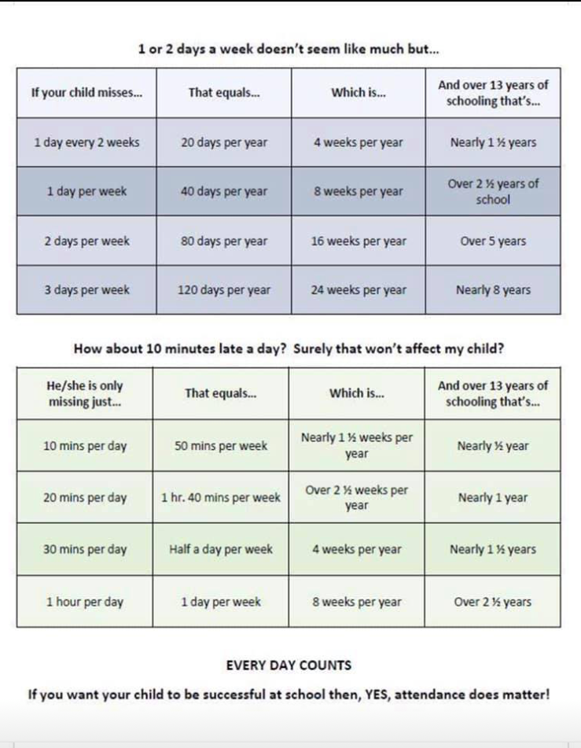

CHS ATHLETICS

CROSS COUNTRY 2019
Tentative Schedule; TIMES are approximate
DATE | DAY | TIME | OPPONENT | LOCATION | DEPARTURE TIMES* | TEAMS
31 AUG | SATURDAY | 8:00 | MORA HIGH SCHOOL | MORA | I 25 to mora | MS, JV, V
14 SEPT | SATURDAY | 8:00 | TAOS CROSS COUNTRY INVITE | TAOS | (through Moreno Valley) 5:30a.m | MS, JV, V
21 SEP | SATURDAY | 8:00 | RON VALDEZ @ PECOS | PECOS | TBA (through Moreno Valley) 5:30a.m | MS, JV, V
28 SEPT | SATURDAY | 8:30 | CAPITAL CITY INVITATIONAL | SANTA FE | Departure 5:30 a.m | MS, JV, V
5 OCT | SATURDAY | 8:00 | JOHN GRIMLEY INVITE | SFIS | Depart at 530a.m going through valley | MS, JV, V
12 OCT | SATURDAY | 2:30 | NORTHERN NM CHALLENGE | SANTA FE | TBA (through Moreno Valley) depart 5:00 a.m | MS,JV, V
19 OCT | SATURDAY | 8:00 | RIO RANCHO JAMBOREE | RIO RANCHO | High School | V
25 Oct | Friday | 3:30 | CIMARRON INVITE | CIMARRON | HOME | V,JV,MS
1ST/ 2 NOV | SATURDAY | TBD | DISTRICT MEET | TBA | TBA | V
9 NOV | SATURDAY |  | STATE XC MEET | TBA | TBA | V

Volleyball 2019

DATE | DAY | TIME | OPPONENT | LOCATION | DEPART* | TEAMS
*August 24 | Saturday |  | Scrimmage | SFIS | 6:30am | Varsity
*Aug 30/Aug 31 | Fri/Sat | TBD | Mountainair Tournament | Mountainair | TBD | V
September 3 | Tuesday | 4:30 | Maxwell | Eagle Nest | N/A | EN MS
September 6 | Friday | 4:00 | Pecos | Pecos | 1:00 | Cim a&b
September 7 | Saturday | 4:00 | Penasco | Penasco |  | Cim JH/JV/V
September 9 | Monday | 4:30 | Questa | Questa |  | JV/V
*Sept 13/14 | Friday - Saturday | 3:00 and 9:00 | Anna Archuleta Tournament | Cimarron | Pool Play  begins @ 3:00 | Varsity
 |  |  | Dora, Quemado, , MV, Cimarron,  Des Moines, Springer, Penasco, Questa |  |  | Varsity
September 20 | Friday |  | Penasco | Cimarron |  | EN JH/JV/V
September 24 | Tuesday | 4:30 | Maxwell | Maxwell | 2:00 | EN MS
September 25 | Wednesday | 12:00 | Pecos | Cimarron | 4:00 | Cim/ EN
September 27 | Friday | 5:00 | Roy/Mosquero | Cimarron |  | EN/Varsity
September 28 | Saturday | 8:30 am | Eagle Nest Tournament | EN | 7:30 | Cim2, EN2 , Maxwell, WM, Questa 2
September 30 | Tuesday | 3:00 | Clayton | Clayton | 12:00 | CIM/EN
*October 5 | Saturday | 5:00 | Springer | Cimarron |  | EN/Varsity
October 8 | Tuesday | 3:00 | Clayton | Cimarron |  | EN /CIM
*October 11 | Friday | 4:30 | Maxwell | Cimarron |  | Cim MS/V
*October 12 | Saturday | 4:00 | Des Moines | Des Moines | 12:30 | Varsity
*October 14 | Monday | 5:00 | Wagon Mound | Cimarron |  | EN/Varsity
*October 23 | Wednesday | 5:00 | Wagon Mound | Wagon Mound |  | CIM MS/Varsity
*October 24 | Thursday | 5:00 | Springer | Springer | 3:30 | CIM/Varsity
*October 26 | Saturday | 4:00 | Des Moines | Cimarron |  | V
*October 31 | Thursday | 4:30 | Maxwell | Maxwell | 2:00 | Cim MS/Varsity
*Nov 1 | Friday | 5:00 | Roy/Mosquero | Mosquero | 3:30 | CimMS/V
Nov 2 | Saturday | 5:00
 | Sunday | 1:00 | District Meeting (SHS)
 |  |  | District Volleyball Tournament | TBD
 |  |  | State Volleyball Tournament | TBD

Please see the calendar of events for September on the next page.

Check out the district website, www.cimarronschools.org, for athletic schedules, school and district information, the monthly newsletter, and much more!

If you, or your organization, have any announcements, events, etc. to be included in our monthly newsletters, please email it to jmartinez@cimarronschools.org by the 3rd Friday of the month, in order for it to go out on the next month's newsletter. If you would like a hard copy of our newsletter sent home with your child instead of receiving it via email or the website, please email Jody Martinez at the email address above.

